Ethical Competency
Candidate Instructions
(Online test)

OFFICIAL
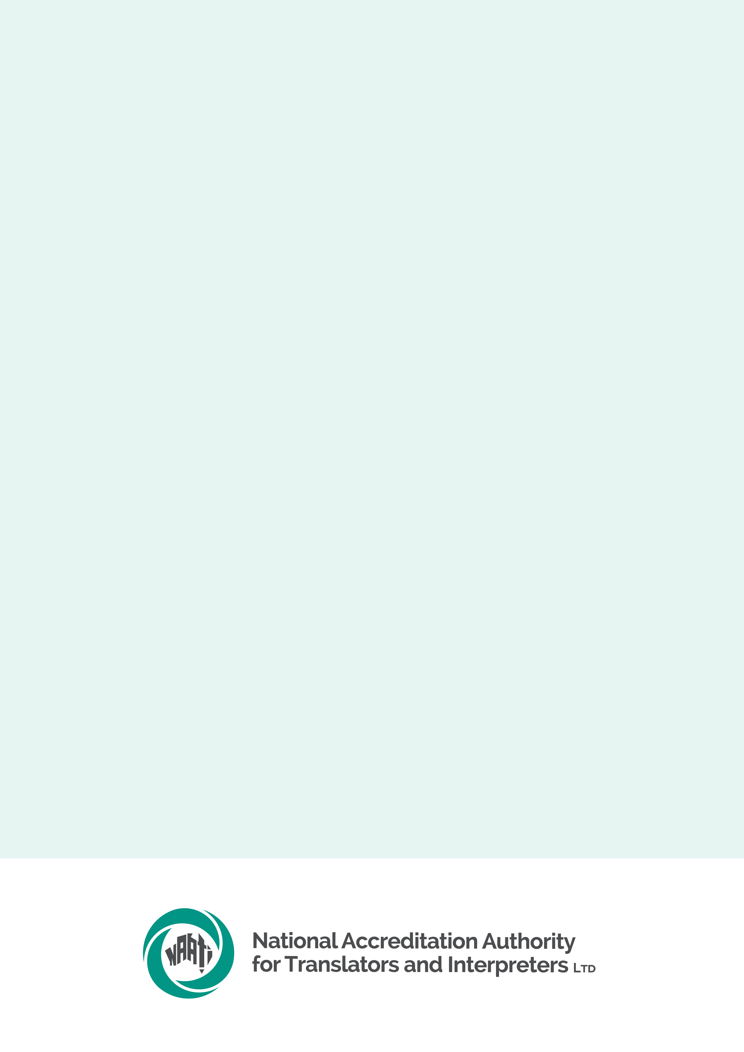

Contents
Reminder for candidates 3
Equipment & system requirements 3
Laptop or computer 3
Internet connection 3
Preparing for test day 4
Before test day 4
System check 4
What you will need 4
Identity document 4
System requirements 4
What NAATI will and will not provide 5
Test conditions 5
Leaving the test environment 5
Behaviour on test day 5
Use of resources 5
Use of electronic devices 5
Confidentiality 5
Test overview 6
On test day 6
Test description 6
Test duration 6
Test supervision and support from NAATI 6
Assessment & results 7
Assessment 7
Results 7
Re-sitting the test 7

Reminder for candidates
- Familiarise yourself with the Ethical Competency test page
< https://www.naati.com.au/certification/prerequisites-training/ethical-competency/ >
- Read the Terms and conditions < https://www.naati.com.au/resources/terms-and-conditions/ >

Equipment & system requirements
Please read the specifications carefully below.

Laptop or computer
- Working camera and microphone.
- A power cord/connector.
- Windows 10 or higher, Mac OS 11 (Big Sur) or higher, ChromeOS and most Linux distributions (64-bit Ubuntu 14.04+, Debian 8+, openSUSE 13.3+, or Fedora Linux 24+).
- Latest version of Google Chrome browser installed.
- You will be prompted to download and install the ProctorExam Google Chrome extension during your system check.
- Note: The test platform requires the use of Google products. Candidates must be able to access and use these without interference to sit the test. A work laptop or computer may block access to the test platform, restricting access to the platform.

Internet connection
- At least 25mbps download speed, 10mbps upload speed, and internet speed (ping) of below 25 milliseconds
- You can check your internet speed on www.speedtest.net
- Note: using a public WiFi network or computer with firewalls (such as a work or laptop computer) that block access to the test platform may result in access to the test being restricted
It is your responsibility to make sure your equipment is suitable and will function for the entire test. We recommend that your electronic devices be connected to a power source for the duration of your test. Note that small screens (such as laptop screens) may make it harder for you to see everything clearly.

Preparing for test day

Before test day
Candidates have access to NAATI’s Ethical Competency test preparation course on NAATI Learn to prepare for this test. The course takes about 20 hours of study time.
The Ethical Competency test is delivered online via NAATI’s testing platform, Televic. NAATI uses an online proctoring program called ProctorExam to make sure all tests are valid and are sat by the correct person.
Make sure you have the right equipment (see section: ‘What you will need’ below).

System check
A week prior to your test date, you will receive an email from ProctorExam with instructions on how to set up for your test.
When you click the link, you will be prompted to complete a system check. The system check must be completed using the same setup as you will use on your test day (i.e. same computer, phone, location, internet connection).
- If you have not received this email from ProctorExam, check your spam/junk folder. If it is not there, please email us at onlinetesting@naati.com.au so that we can follow up for you.
Watch the video below for instructions.
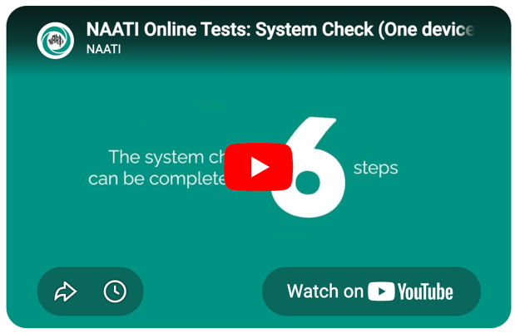
https://www.youtube.com/watch?v=kw0Ba1mNf-0

What you will need

Identity document
You must have a photo identity document (passport or Australian driver’s licence) ready when you begin your test.

System requirements
See section: ‘Equipment & system requirements‘ above.

What NAATI will and will not provide
During the test NAATI will provide:
- Live Support in accessing the NAATI testing platform and basic technical support with a NAATI staff member via live chat. (For any questions or concerns prior the test date please email onlinetesting@naati.com.au)
NAATI will not provide:
- Technical support should you experience issues with your equipment

Test conditions
You must observe these conditions. If you do not, NAATI may cancel your test or not issue your test result. In this case, you will not receive a refund of your test fee.

Leaving the test environment
Leaving the test environment during a test session is not allowed. In exceptional circumstances, you may request a 5-minute bathroom break during your test. This must be requested via the live chat before leaving the room.

Behaviour on test day
You are expected to be courteous and respectful towards NAATI staff. You cannot communicate with other external parties (e.g. via chat) on the test day once your test has started.

Use of resources
This is a closed book test, so you are not allowed to use any resources (printed or digital) during the test.

Use of internet and electronic devices
You are not allowed to use any electronic devices apart from those used in taking the test. Mobile phones, laptops, tablets and other smart devices such as smart watches must be turned off and positioned in a different room. Only one screen is allowed at any given time. You must not use any communication and recording functions of devices used for your test during the test session.

Confidentiality
All test materials are the property of NAATI. You are not permitted to make or take away copies, paper or electronic, of any test material, or reproduce the test or communicate the test content to other candidates or a third party.

Test overview

On test day
Note: You will not receive a link to sit the test until you have completed the system check.
The test must be completed in a location that is free of distractions, background noise and other people. The test location will be checked at the start of the test.
You will need to provide proof of your identity by showing your identity document (passport or Australian driver’s licence) to the camera when asked, prior to beginning your test.
The test will be audio and video-recorded for identity verification, assessment and auditing purposes.
Watch the video below for instructions on setting up on test day.
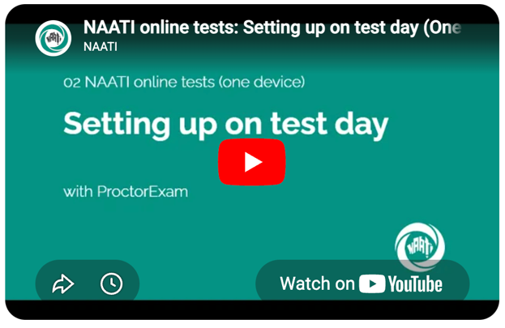
https://www.youtube.com/watch?v=asNcZ6aaab0

Test description
There are four different Ethical Competency tests relating to the four different codes of ethics (see ‘Prerequisites‘ tab). You will choose the test that is specific to the credential you are applying for.
You only need to complete one test, even if you have applied for multiple credentials.
The Ethical Competency test is conducted online and consists of 45 questions. All questions are in English.
- 10 Matching statements questions: each question asks you to match statements from the relevant code of ethics to individual principles.
- 20 Multiple choice questions: each question relates to the application of one ethical principle.
- 15 Multiple choice questions: scenario-type questions depicting an ethical dilemma – you must choose the best course of action based on the relevant ethical principle out of the options available.

Test duration
Once you start the test, you will have 120 minutes to complete all questions.

Test supervision and support from NAATI
The test will be audio and video-recorded for identity verification, assessment and auditing purposes.
On your test day, NAATI’s Digital Testing team will be available via live chat during your test to assist with any technical issues or you can get help by emailing onlinetesting@naati.com.au.

Assessment & results

Assessment
The Ethical Competency test will assess:
- Your knowledge of the relevant code of ethics
- Your ability to identify ethical issues in a broad range of interpreting and/or translation scenarios; and
- Your ability to apply the relevant principle/value of the code to each scenario.
Each correctly answered question is worth:
- Questions 1-30: 1 point
- Questions 31-45: 2 points (partially correct answers count for 1 point)
- Incorrect answers and unanswered questions receive 0 points.
To pass the test you must score 80% overall, or 48 points out of a maximum of 60 points.

Results
At the end of each test session, all test attempts will be reviewed as part of NAATI’s quality assurance process, and you will be notified of your result via email within 5 business days of your test.

Re-sitting the test
- Paid reviews of test results and supplementary tests are not available for Ethical Competency tests.
- You will be offered a re-sit of the whole test if you fail the test. You will need to pay the test fee again for each additional test.
- You may have a maximum of two test re-sits. After the third failed attempt, your credential application will be deemed unsuccessful.

